Lab Report Week 2

Task 1

Running man simulation constant velocity:

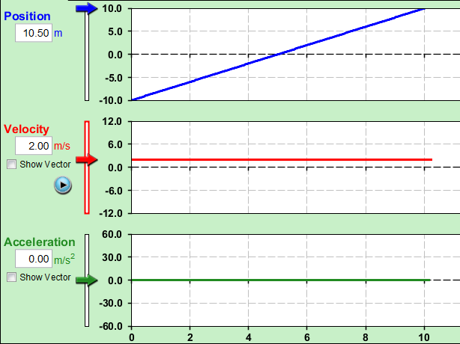

As there is no acceleration yet a constant velocity the running man never runs any faster than when he first started so both velocity and acceleration are constant values. Where as position slowly increases in a straight line as he never gains any speed

Running man simulation constant acceleration:

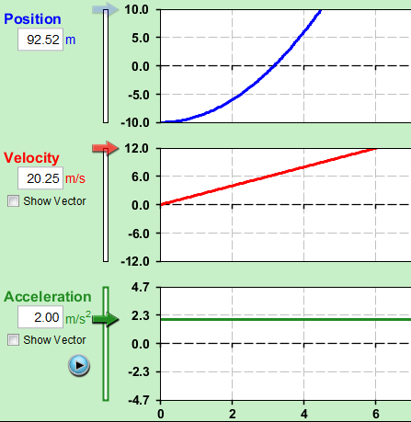

Because the acceleration is at a constant the velocity of the running man increases at a constant rate creating a steady straight line. The position of the man increases over time creating a curve as his velocity increases

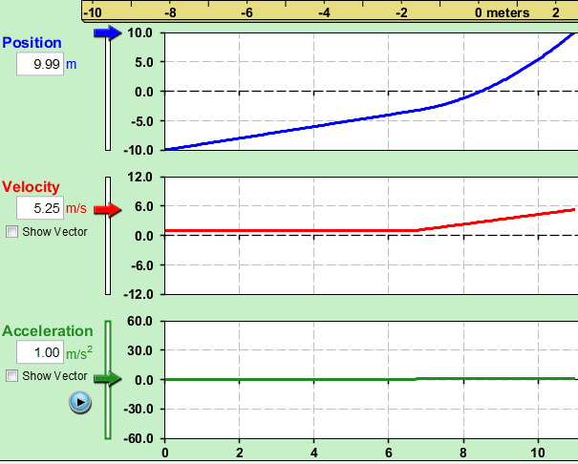

Switching Constants – When switching from constant velocity to constant acceleration the positional graph changes due to the change in acceleration meaning more distance is covered by the running man in a shorter time. The velocity graph also increases when the acceleration is increased as the velocity is increased over time due to the acceleration. The acceleration graph remains a constant in both instances.

Questions

1. Velocity is change in distance over change in time.   
   Acceleration is change in velocity over change in time
2. RCA
3. Time in seconds is equal to the distance covered in meters multiplied by the velocity in meters per second.
4. Average, as Instantaneous does not show an entire journey
5. Racing games

Task 2

1. Prediction: The man will be moving at a constant pace so the velocity line will remain constant where as the distance line will increase at a steady pace.

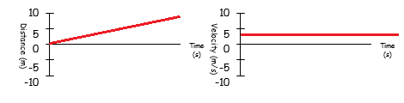

Verification:

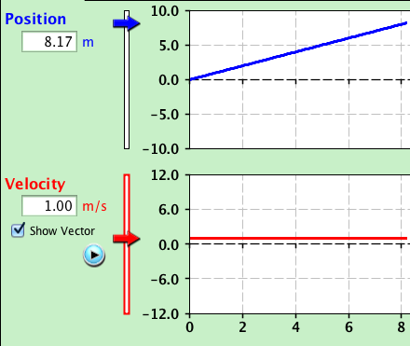

B) Prediction: The velocity line will remain the same as the last example however the distance line will increase at a much faster pace.

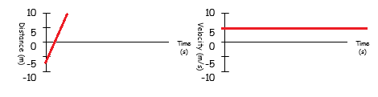

Verification:

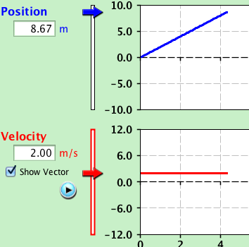

1. Prediction: Both lines will remain constant, as the man is no gaining any velocity or distance whilst stood still.

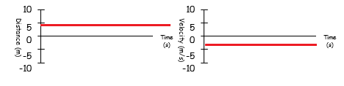

Verification:

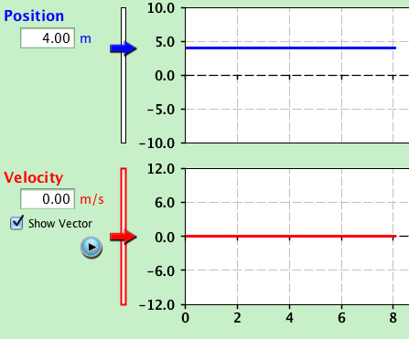

1. Prediction: The distance graph will show a sharp rise upwards then a slow decrease downwards, the velocity graph will show a constant velocity until the man turns which then will cause the graph to dip the line will then continue on a constant at its new position as the man moves back to 0.

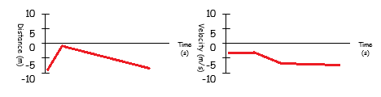

Verification:

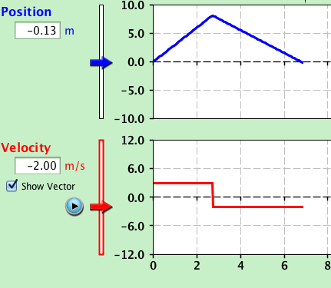

1. Prediction: the velocity graph will move at a constant the entire time, where as the distance graph will have a gradual decline.

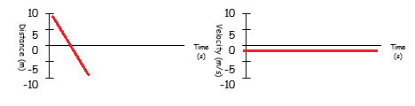

Verification:

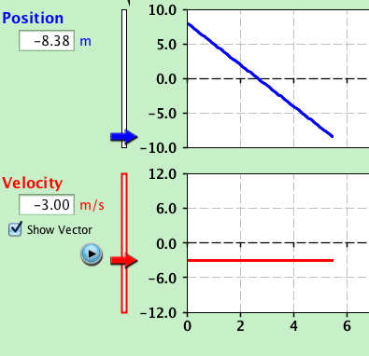

1. Prediction: the distance graph will grow with an exponential curve as the man accelerates, and the velocity graph will gradually increase

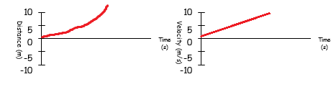

Verification:

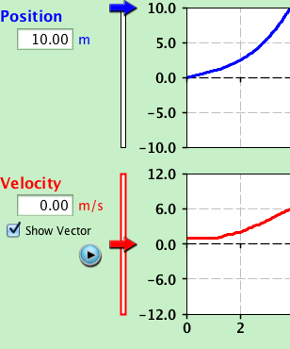

1. Prediction: as the man moves from where he stands the distance will gradual increase until he stops again at which point it will be constant, the velocity graph will be constant until he beings to move at which point it will spike and level out until he stop at which point it will decrease.

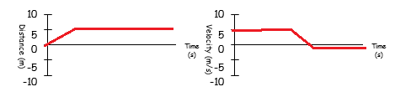

Verification:

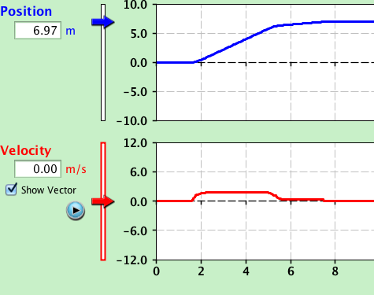

1. Predication: the distance graph will show a small constant until the man moves then it will show steady incline as he moves at a steady space, it will then begin to slowly arc as he begins to slow, the velocity graph will show the velocity graph will be at a constant until he moves at which point it will gradually increase until he begins to slow down which will show a decline in velocity until he come to a rest.

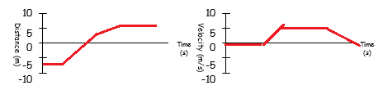

Verification:

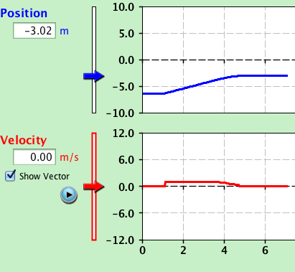

I) Prediction: The man is picking up speed making the distance covered large and the graph steep but the man stops and after his rest the slop is not as rapid as he is moving at a slower pace. The velocity increases as the man speeds up but when he stops the velocity drops and then the man starts moving again so the velocity increases until he finally stops.

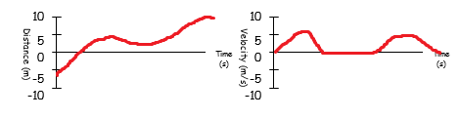

Verification:

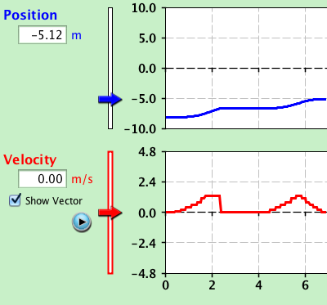

J) Prediction: As he increases his speed the distance covered increases, which causes the distance graph to curve. The velocity graph shows a constant increase.

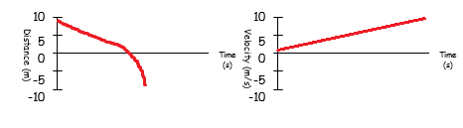

Verification:

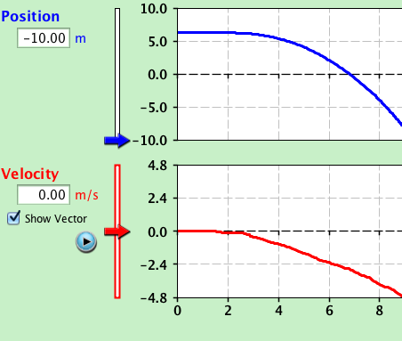

6) Some of our prediction where wrong as we had forgot that the velocity graph would go the other way as J) for an example we had predicted the velocity to increase where as it decreased.

7) A man walks slow pace to his house from the tree, then after pausing for a moment and realising he has having forgotten his wallet at the tree he then briskly returns to the tree.

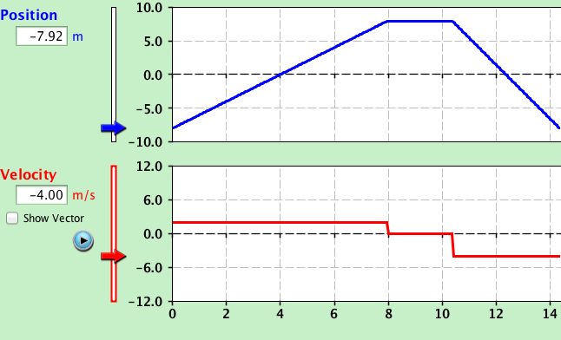

We set the graphs to make the man walk to his house from the tree at 2m/s he then followed this motion until he reached the house, the velocity is then set to 0m/s for a few moments as he realises he has forgotten something, the graph is then set at -4m/s to show the man briskly returning to his wallet at the tree.

8) A man jogs towards a house which he uses as a marking point, his position increase quickly as he jogs, he then begins to tire and slowly comes to a stop where he rests for a few moments, he then begins to jog home again slowly picking up speed until he begins to tire again on his return journey and slows down.